1. **Spring MVC**:
   1. Framework to build web app based on MVC Design Pattern, leveraging features of Core Spring Framework (IoC, DI)
2. **Request Flow**: Browser 🡺Front Controller (DispatcherServlet) 🡺 Your Controller 🡺 View Template 🡺 response to browser.(passing model object among them)
3. **Spring MVC Benefits**:
   1. Spring way of building web app UIs in java, b. Reusable UI Components (Spring JSP Custom Tags), c. Session/Application Tracking D. Validating, Converting and formatting form data. e. flexible configuration for view layer.
4. **Components of a Spring MVC Application**:
   1. **Web Pages** + **Beans** + **Spring Configuration Files**
5. **Spring MVC Front Controller**: Known as **DispatcherServlet,** part of spring mvc jar, delegates request to controller.
6. **Controller**: receives request, execute business logic, place data in model then sends to appropriate view template.
7. **Model** Contains data to display on page, comes from database or web service.
8. **View Template:** Spring supports many view templates, created by developer, most commont JST+JSTL, displays data in model.   
   Other view templates: **Thymeleaf, Groovy, Velocity, Freemarker** etc.
9. **Spring MVC Configuration**:
   1. 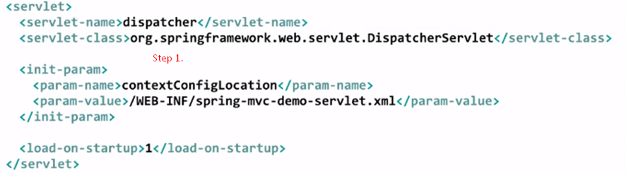
   2. Mapping 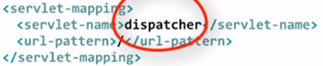
   3. Component Scanning: 